

**INTRODUCCIÓN AL CÁLCULO-MA611**

**Semana N°2 Sesión 1**

**Números reales, desigualdades e intervalo.**

**Logro de la sesión**

El alumno, al término de la clase:

* Reconoce a qué conjunto pertenecen ciertos números.
* Determina la unión e intersección entre intervalos.
* Lee, interpreta y resuelve inecuaciones de primer grado, determinando el conjunto solución.

**Diagrama de los conjuntos numéricos**

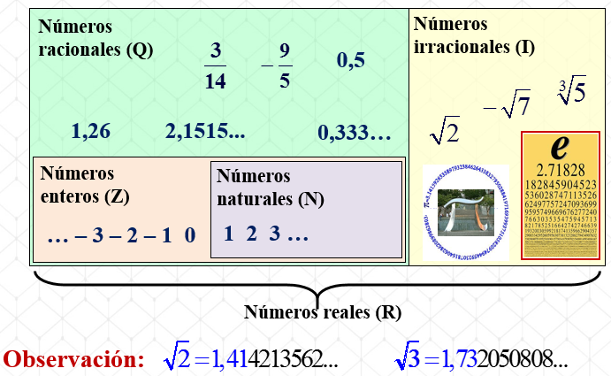

**Ejercicio 1:**

Marque un check en el cuadro para indicar el conjunto al que pertenece cada uno de los siguientes números:

|  |  |  |  |  |  |
| --- | --- | --- | --- | --- | --- |
|  | **Naturales (N)** | **Enteros (Z)** | **Racionales (Q)** | **Irracionales (I)** | **Reales (R)** |
| 0 |  |  |  |  |  |
|  |  |  |  |  |  |
| 1,342 |  |  |  |  |  |
|  |  |  |  |  |  |
| – 4,33… |  |  |  |  |  |
| π |  |  |  |  |  |
|  |  |  |  |  |  |
|  |  |  |  |  |  |

**Recta numérica real**

Es una recta que establece una correspondencia entre los números reales y los puntos de la recta.

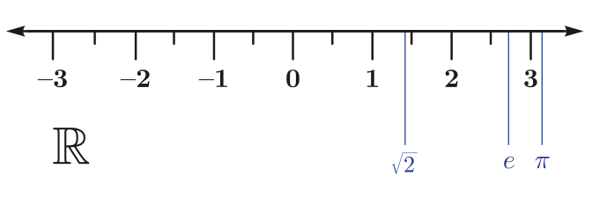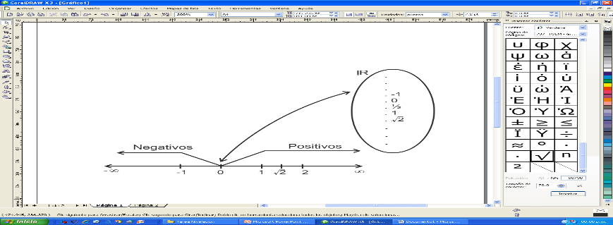

**Relación de orden**

Dos números reales *a* y *b*, pueden compararse mediante la relación de orden.

***a* < *b*** donde **(*a* ≠ *b*)**, se lee “*a* es menor que *b*” o “*b* es mayor que *a*”.

***a* ≤ *b*** se lee “*a* es menor o igual que *b*” o “*b* es mayor o igual que *a*”.

**Ejemplos**

|  |  |
| --- | --- |
| **Relación de orden** | **Lectura** |
| *x* > 2 | **x es mayor que 2** |
| -3 < *x* | **x es mayor que – 3** |
| 6 > *x* |  |
| *x* < 15 |  |
| 4 < *q* < 10 |  |

**Aplicaciones**

* En ese closet hay al menos 39 camisas de vestir**: C** > 39
* El triple del número de estudiantes de Administración no supera a 1500**: 3*x*** < 1500
* La edad del profesor es a lo más de 50 años**: *x*** < 50
* Mi deuda excede los 2400 soles**:**__**_________________________________________________**
* La cantidad de producción varía entre 1200 y 2100 unidades**:** **____________________________**

**Intervalo**

Es un subconjunto de los números reales (***R***), mediante el cual se expresan la solución de las inecuaciones. Estos intervalos se representan gráficamente en la recta real.

**Ejemplo:**

La desigualdad: −5 < *x ≤* 6 se representa gráficamente

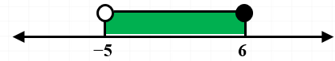

y el intervalo es: ]-5; 6]

**Intervalos acotados**

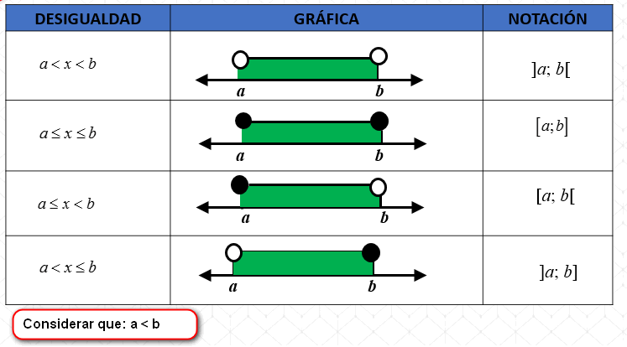

**Intervalos no acotados**

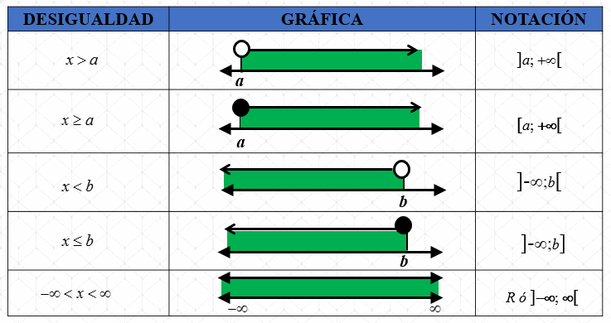

**Operaciones con intervalos**

**Intersección:** Sean *A* y *B* dos intervalos, la intersección de *A* y *B* se denota por *A∩B* y se define como todos los valores reales que pertenecen a *A* **y** a *B*.



**Unión:** Sean *A* y *B* dos intervalos, la unión de *A* y *B* se denota por *A*∪*B* y se define como todos los valores reales que pertenecen a *A*, a *B* o a ambos.



**Ejercicio:**

Determine la **intersección** y la **unión** en las siguientes gráficas.

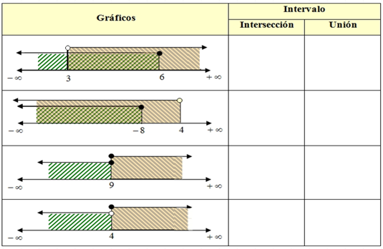

**Ejercicio:**

Si *A =* ]-3; 8] , *B* = ]1; 13[ y *C* = ]14; +∞[

Determine: (*A* ∪ *B* ) ∩ *C*

|  |  |  |  |  |  |  |  |  |  |  |  |  |  |  |  |  |  |  |  |  |  |  |  |  |
| --- | --- | --- | --- | --- | --- | --- | --- | --- | --- | --- | --- | --- | --- | --- | --- | --- | --- | --- | --- | --- | --- | --- | --- | --- |
|  |  |  |  |  |  |  |  |  |  |  |  |  |  |  |  |  |  |  |  |  |  |  |  |  |
|  |  |  |  |  |  |  |  |  |  |  |  |  |  |  |  |  |  |  |  |  |  |  |  |  |
|  |  |  |  |  |  |  |  |  |  |  |  |  |  |  |  |  |  |  |  |  |  |  |  |  |
|  |  |  |  |  |  |  |  |  |  |  |  |  |  |  |  |  |  |  |  |  |  |  |  |  |
|  |  |  |  |  |  |  |  |  |  |  |  |  |  |  |  |  |  |  |  |  |  |  |  |  |
|  |  |  |  |  |  |  |  |  |  |  |  |  |  |  |  |  |  |  |  |  |  |  |  |  |
|  |  |  |  |  |  |  |  |  |  |  |  |  |  |  |  |  |  |  |  |  |  |  |  |  |
|  |  |  |  |  |  |  |  |  |  |  |  |  |  |  |  |  |  |  |  |  |  |  |  |  |

**Inecuaciones de primer grado**

Una inecuación de **primer grado** con una incógnita (inecuaciones lineales), es aquella inecuación que puede reducirse a las siguientes formas generales:

, , , 

donde *a* y *b* son números reales, con *a* ≠ 0.

**Ejemplo:** Resuelva las inecuaciones siguientes:

|  |  |  |  |  |  |  |  |  |  |  |  |  |  |  |  |  |  |  |  |  |  |  |  |  |
| --- | --- | --- | --- | --- | --- | --- | --- | --- | --- | --- | --- | --- | --- | --- | --- | --- | --- | --- | --- | --- | --- | --- | --- | --- |
|  |  |  |  |  |  |  |  |  |  |  |  |  |  |  |  |  |  |  |  |  |  |  |  |  |
|  |  |  |  |  |  |  |  |  |  |  |  |  |  |  |  |  |  |  |  |  |  |  |  |  |
|  |  |  |  |  |  |  |  |  |  |  |  |  |  |  |  |  |  |  |  |  |  |  |  |  |
|  |  |  |  |  |  |  |  |  |  |  |  |  |  |  |  |  |  |  |  |  |  |  |  |  |

1. **
2. 

|  |  |  |  |  |  |  |  |  |  |  |  |  |  |  |  |  |  |  |  |  |  |  |  |  |
| --- | --- | --- | --- | --- | --- | --- | --- | --- | --- | --- | --- | --- | --- | --- | --- | --- | --- | --- | --- | --- | --- | --- | --- | --- |
|  |  |  |  |  |  |  |  |  |  |  |  |  |  |  |  |  |  |  |  |  |  |  |  |  |
|  |  |  |  |  |  |  |  |  |  |  |  |  |  |  |  |  |  |  |  |  |  |  |  |  |
|  |  |  |  |  |  |  |  |  |  |  |  |  |  |  |  |  |  |  |  |  |  |  |  |  |
|  |  |  |  |  |  |  |  |  |  |  |  |  |  |  |  |  |  |  |  |  |  |  |  |  |
|  |  |  |  |  |  |  |  |  |  |  |  |  |  |  |  |  |  |  |  |  |  |  |  |  |
|  |  |  |  |  |  |  |  |  |  |  |  |  |  |  |  |  |  |  |  |  |  |  |  |  |

1. 

|  |  |  |  |  |  |  |  |  |  |  |  |  |  |  |  |  |  |  |  |  |  |  |  |  |
| --- | --- | --- | --- | --- | --- | --- | --- | --- | --- | --- | --- | --- | --- | --- | --- | --- | --- | --- | --- | --- | --- | --- | --- | --- |
|  |  |  |  |  |  |  |  |  |  |  |  |  |  |  |  |  |  |  |  |  |  |  |  |  |
|  |  |  |  |  |  |  |  |  |  |  |  |  |  |  |  |  |  |  |  |  |  |  |  |  |
|  |  |  |  |  |  |  |  |  |  |  |  |  |  |  |  |  |  |  |  |  |  |  |  |  |
|  |  |  |  |  |  |  |  |  |  |  |  |  |  |  |  |  |  |  |  |  |  |  |  |  |
|  |  |  |  |  |  |  |  |  |  |  |  |  |  |  |  |  |  |  |  |  |  |  |  |  |

**Definiciones:**

* Nivel de Producción (*q*): cantidad de unidades que una empresa produce y vende.
* Costo Fijo (*Cf* ): es todo costo que es independiente del nivel de producción.
* Costo unitario de producción (*Cu*): es el costo de producir una unidad.
* Costo total (*C*): es el costo de producir *q* unidades.

***C* = *Cf* + *Cu* *q***

* Precio de venta (*p*): precio al cual se vende una unidad.
* Ingreso (*I*): La cantidad de dinero generada por la venta de *q* unidades, cada una a un precio *p*. $I=p.q$. Utilidad es la diferencia entre Ingreso y Costo, es decir: $U=I-C$

**Aplicaciones:**

Ejemplo 1:

Una empresa manufacturera calcula sus costos y utilidad, en dólares, de *x* decenas de unidades producidas y vendidas a través de las siguientes expresiones: *C* = 23*x* + 2 800 y U = 7*x* – 2 800, respectivamente.

Si logra un ingreso de por lo menos 1 500 dólares, ¿cuál es el mínimo costo que se requiere?

|  |  |  |  |  |  |  |  |  |  |  |  |  |  |  |  |  |  |  |  |  |  |  |  |  |  |
| --- | --- | --- | --- | --- | --- | --- | --- | --- | --- | --- | --- | --- | --- | --- | --- | --- | --- | --- | --- | --- | --- | --- | --- | --- | --- |
|  |  |  |  |  |  |  |  |  |  |  |  |  |  |  |  |  |  |  |  |  |  |  |  |  |  |
|  |  |  |  |  |  |  |  |  |  |  |  |  |  |  |  |  |  |  |  |  |  |  |  |  |  |
|  |  |  |  |  |  |  |  |  |  |  |  |  |  |  |  |  |  |  |  |  |  |  |  |  |  |
|  |  |  |  |  |  |  |  |  |  |  |  |  |  |  |  |  |  |  |  |  |  |  |  |  |  |
|  |  |  |  |  |  |  |  |  |  |  |  |  |  |  |  |  |  |  |  |  |  |  |  |  |  |
|  |  |  |  |  |  |  |  |  |  |  |  |  |  |  |  |  |  |  |  |  |  |  |  |  |  |
|  |  |  |  |  |  |  |  |  |  |  |  |  |  |  |  |  |  |  |  |  |  |  |  |  |  |
|  |  |  |  |  |  |  |  |  |  |  |  |  |  |  |  |  |  |  |  |  |  |  |  |  |  |
|  |  |  |  |  |  |  |  |  |  |  |  |  |  |  |  |  |  |  |  |  |  |  |  |  |  |

Ejemplo 2:

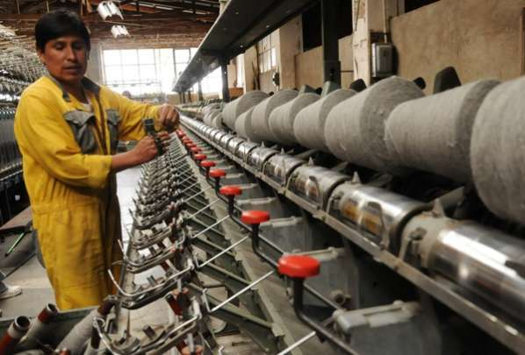El dueño de una fábrica de chompas de lana de alpaca, determina que el costo unitario por la fabricación de cada chompa es de $25. Si los costos fijos ascienden a $ 3 000 al mes y el precio de venta unitario es de $125. Si quiere lograr una utilidad entre $ 5 000 y $ 6 000 mensuales.

1. ¿Cuál es la cantidad mínima y máxima de chompas que se deben producir y vender?
2. Entre qué valores se encuentra el ingreso.

|  |  |  |  |  |  |  |  |  |  |  |  |  |  |  |  |  |  |  |  |  |  |  |  |  |  |
| --- | --- | --- | --- | --- | --- | --- | --- | --- | --- | --- | --- | --- | --- | --- | --- | --- | --- | --- | --- | --- | --- | --- | --- | --- | --- |
|  |  |  |  |  |  |  |  |  |  |  |  |  |  |  |  |  |  |  |  |  |  |  |  |  |  |
|  |  |  |  |  |  |  |  |  |  |  |  |  |  |  |  |  |  |  |  |  |  |  |  |  |  |
|  |  |  |  |  |  |  |  |  |  |  |  |  |  |  |  |  |  |  |  |  |  |  |  |  |  |
|  |  |  |  |  |  |  |  |  |  |  |  |  |  |  |  |  |  |  |  |  |  |  |  |  |  |
|  |  |  |  |  |  |  |  |  |  |  |  |  |  |  |  |  |  |  |  |  |  |  |  |  |  |
|  |  |  |  |  |  |  |  |  |  |  |  |  |  |  |  |  |  |  |  |  |  |  |  |  |  |
|  |  |  |  |  |  |  |  |  |  |  |  |  |  |  |  |  |  |  |  |  |  |  |  |  |  |
|  |  |  |  |  |  |  |  |  |  |  |  |  |  |  |  |  |  |  |  |  |  |  |  |  |  |
|  |  |  |  |  |  |  |  |  |  |  |  |  |  |  |  |  |  |  |  |  |  |  |  |  |  |
|  |  |  |  |  |  |  |  |  |  |  |  |  |  |  |  |  |  |  |  |  |  |  |  |  |  |
|  |  |  |  |  |  |  |  |  |  |  |  |  |  |  |  |  |  |  |  |  |  |  |  |  |  |

**Reflexión:**

1. ¿Las inecuaciones mostradas tienen el mismo conjunto solución?

** y

|  |  |  |  |  |  |  |  |  |  |  |  |  |  |  |  |  |  |  |  |  |  |  |  |  |  |
| --- | --- | --- | --- | --- | --- | --- | --- | --- | --- | --- | --- | --- | --- | --- | --- | --- | --- | --- | --- | --- | --- | --- | --- | --- | --- |
|  |  |  |  |  |  |  |  |  |  |  |  |  |  |  |  |  |  |  |  |  |  |  |  |  |  |
|  |  |  |  |  |  |  |  |  |  |  |  |  |  |  |  |  |  |  |  |  |  |  |  |  |  |

2. ¿Dada  , se cumple que el ?

|  |  |  |  |  |  |  |  |  |  |  |  |  |  |  |  |  |  |  |  |  |  |  |  |  |  |
| --- | --- | --- | --- | --- | --- | --- | --- | --- | --- | --- | --- | --- | --- | --- | --- | --- | --- | --- | --- | --- | --- | --- | --- | --- | --- |
|  |  |  |  |  |  |  |  |  |  |  |  |  |  |  |  |  |  |  |  |  |  |  |  |  |  |
|  |  |  |  |  |  |  |  |  |  |  |  |  |  |  |  |  |  |  |  |  |  |  |  |  |  |

3. Si *x* representa el número de producción de polos. En el enunciado: “Las cantidades de polos no exceden los 1200”. ¿Su expresión matemática será:  ?

|  |  |  |  |  |  |  |  |  |  |  |  |  |  |  |  |  |  |  |  |  |  |  |  |  |  |
| --- | --- | --- | --- | --- | --- | --- | --- | --- | --- | --- | --- | --- | --- | --- | --- | --- | --- | --- | --- | --- | --- | --- | --- | --- | --- |
|  |  |  |  |  |  |  |  |  |  |  |  |  |  |  |  |  |  |  |  |  |  |  |  |  |  |
|  |  |  |  |  |  |  |  |  |  |  |  |  |  |  |  |  |  |  |  |  |  |  |  |  |  |
|  |  |  |  |  |  |  |  |  |  |  |  |  |  |  |  |  |  |  |  |  |  |  |  |  |  |
|  |  |  |  |  |  |  |  |  |  |  |  |  |  |  |  |  |  |  |  |  |  |  |  |  |  |